**LAPORAN CODE COMPETENCE**

**QA WEEKLY TASK 2**

**Audyva Irefilevitasari Alifia**

Quality Engineer-A, Alterra

Email: audyvairefilevitasarialifia9@gmail.com

**Universitas Brawijaya**

1. Kerjakan tugas berikut: Login Produk Cart User  
   <https://docs.google.com/document/d/1tyfdij6QrYdxxhU5zcH8ce7J3hAkjZSqA3LhxQXR-zc/edit?usp=sharing>

Jawab:

1. Link Dokumentasi Testrail Results: <https://drive.google.com/drive/folders/1zDXns2VS3XcVuBEknbxhSEF4bSnRuqsO?usp=share_link>
2. Link file Postman: <https://drive.google.com/file/d/1GSSZWSZkH8Qga-JPZ8OU9pJ9_Mqi2cv6/view?usp=share_link>
3. Link file zip REST Assured Results: <https://drive.google.com/file/d/1FfBtqOhAYTLIPo0YG0cFurH1PcJfhirT/view?usp=share_link>
4. Link Folder REST Assured Results: <https://drive.google.com/drive/folders/1xDRMjtE203Fk7VvwVRcOy8h2pQYwqMTP?usp=share_link>
5. Results REST Assured:
6. Hasil di Terminal

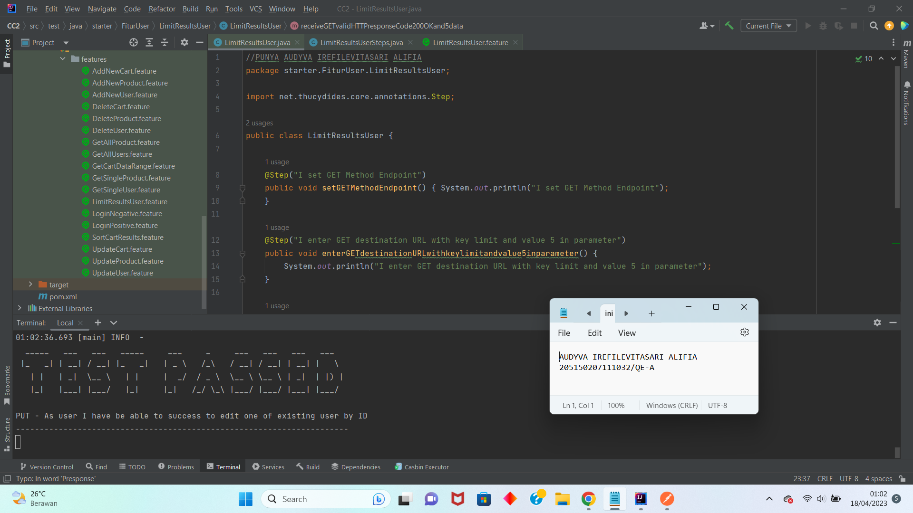

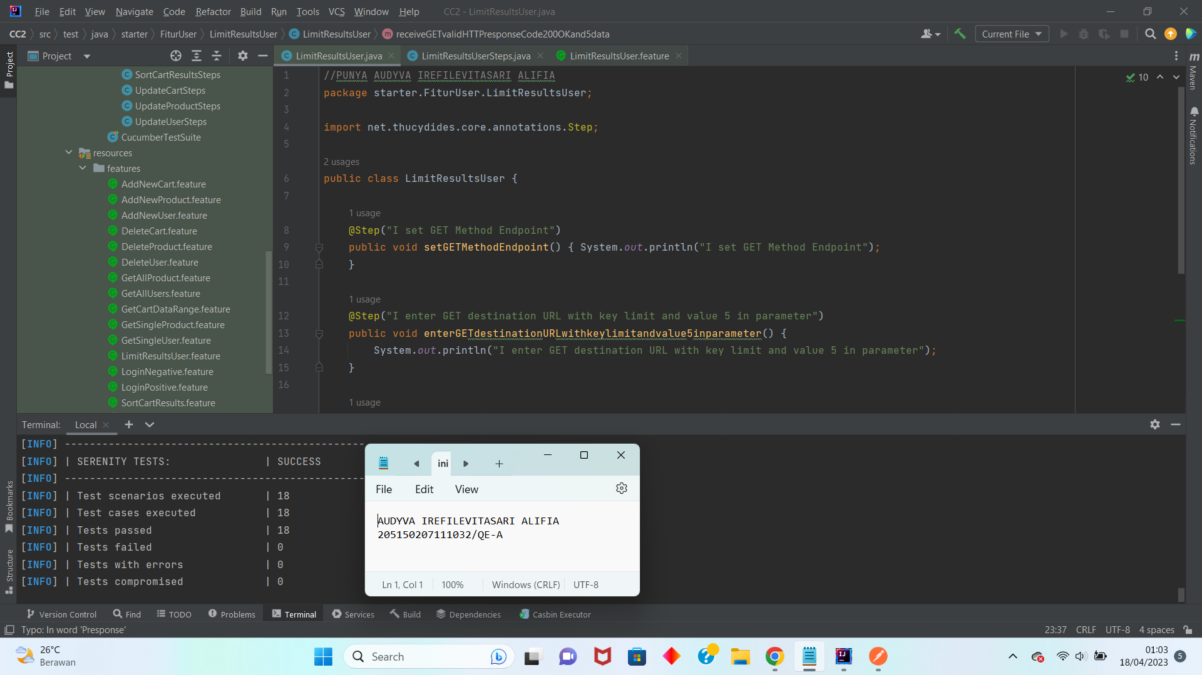

1. Hasil Full Report HTML File Serenity BDD

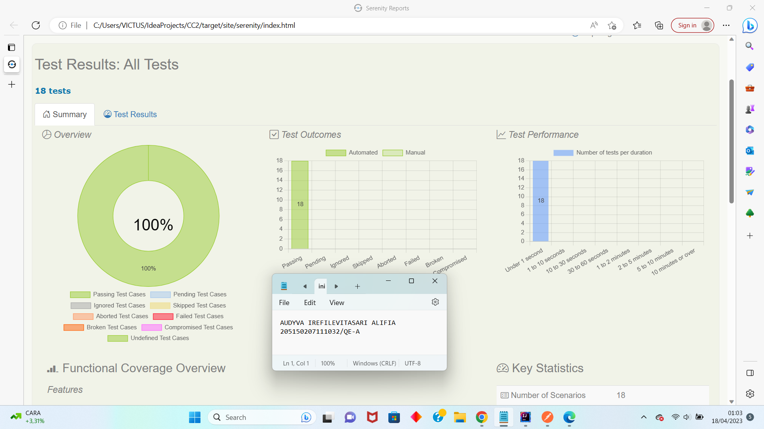

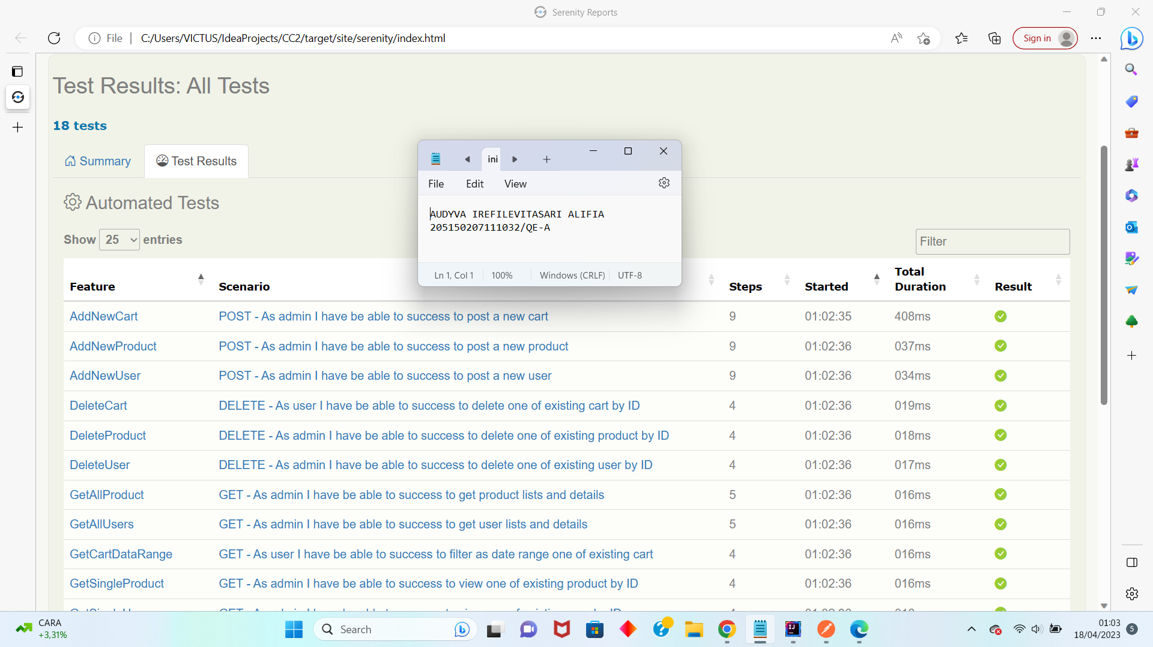

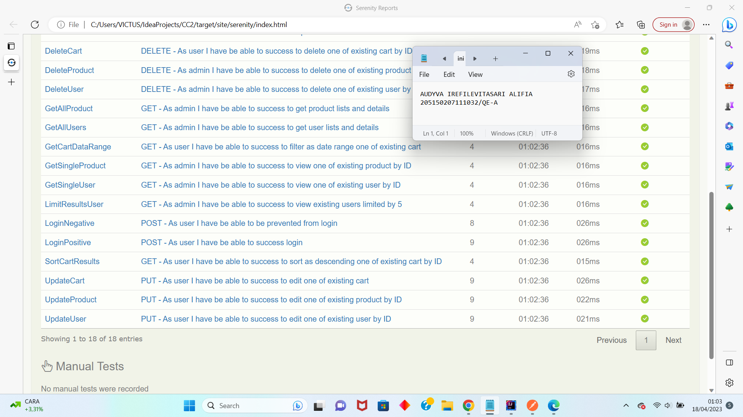

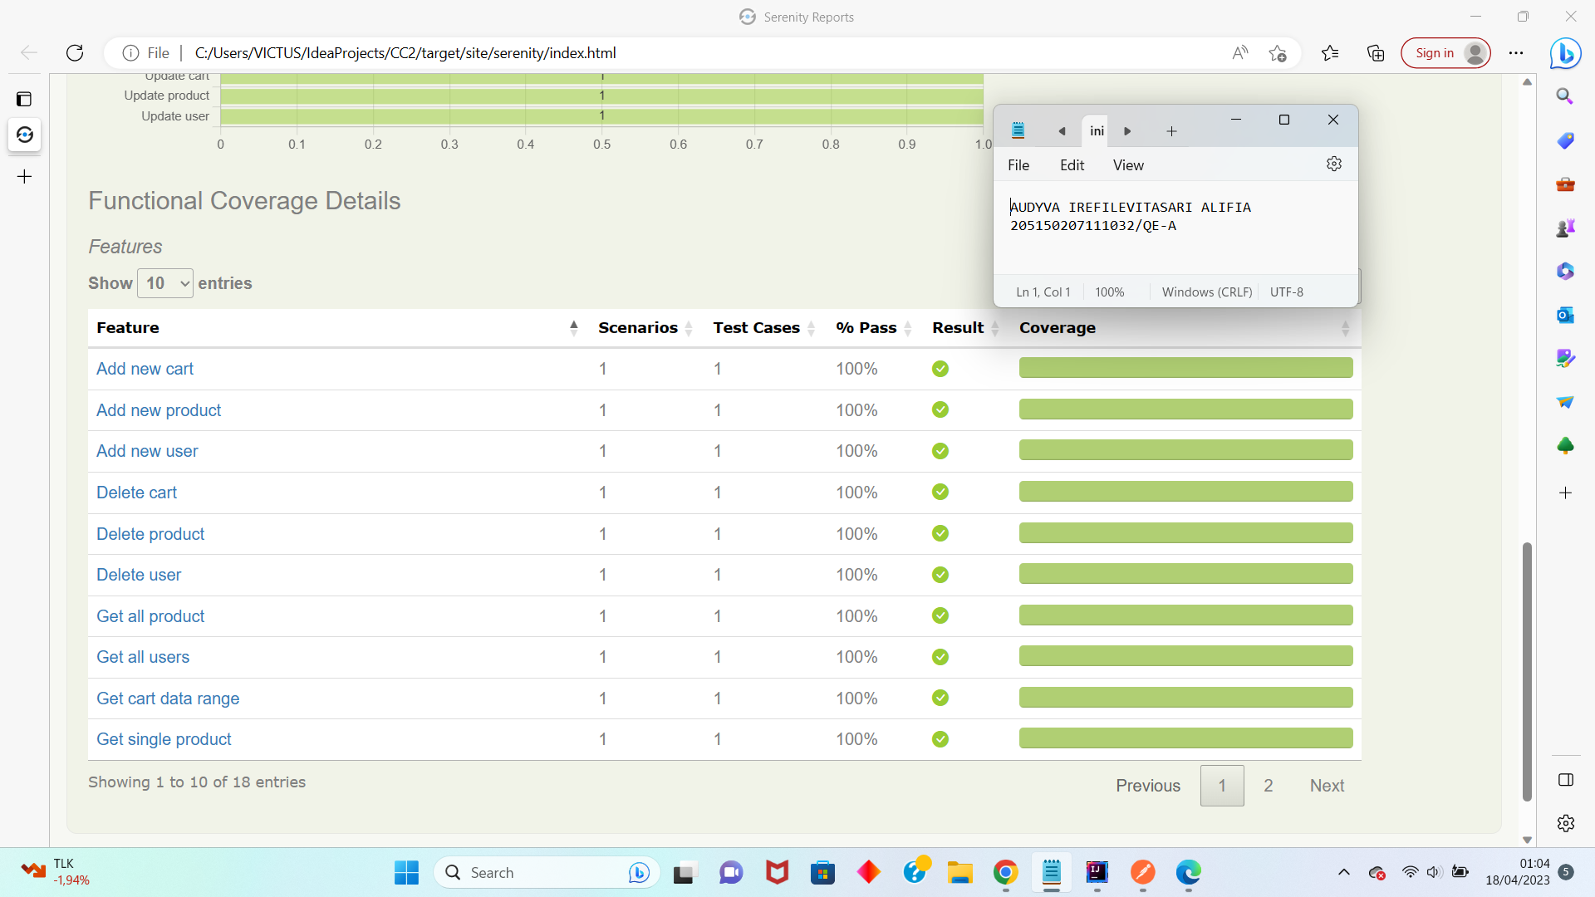

1. Results tiap fitur dengan scenario dan testcase-nya di Postman:
2. Fitur Login

* Scenario login

1. Login Positive with Valid Username and Password

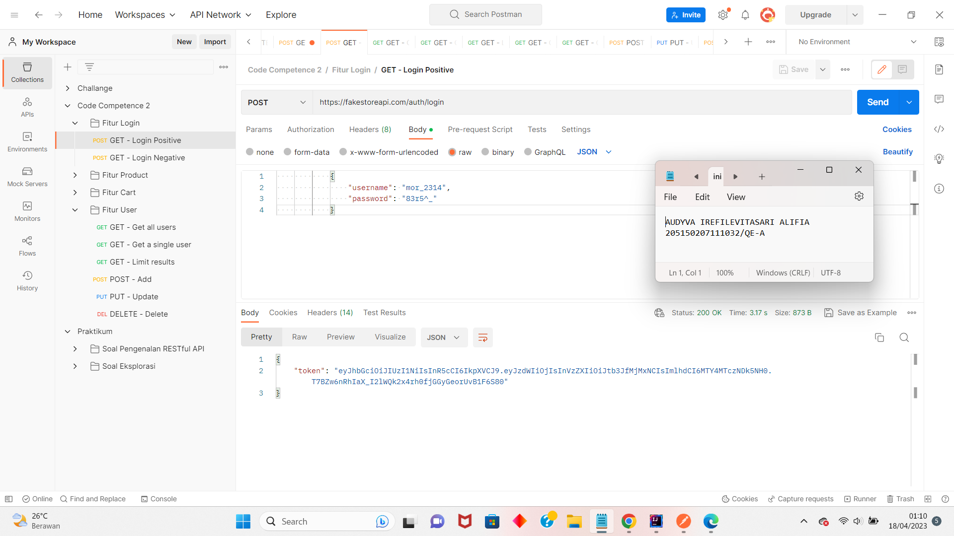

1. Login Negative with Invalid Username and Valid Password

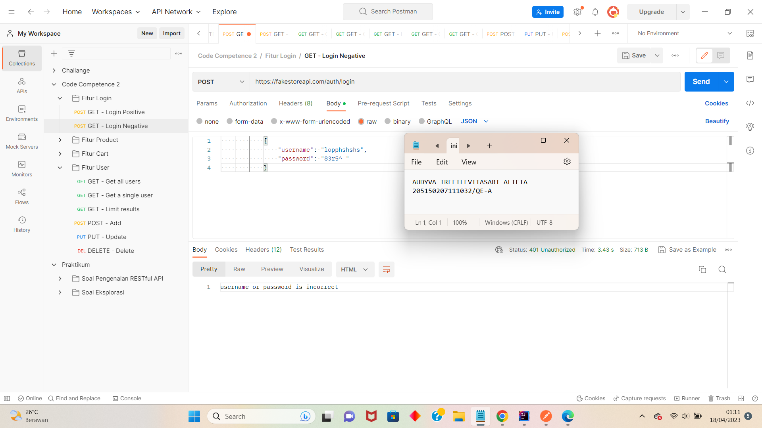

1. Fitur Product

* Scenario GET

1. Get all products

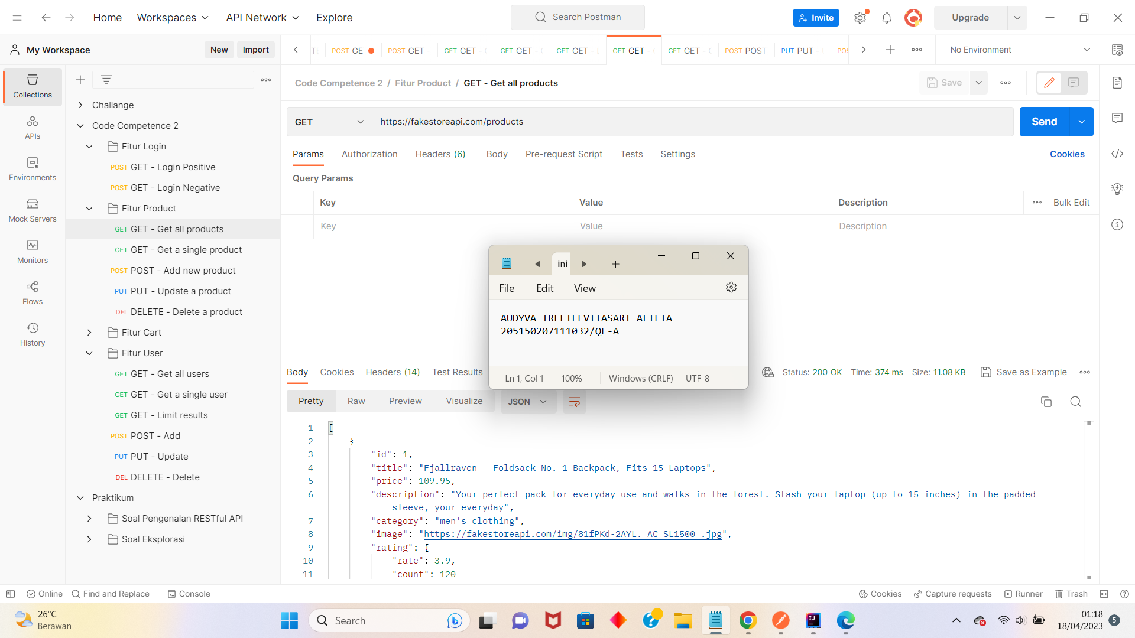

1. Get a single product

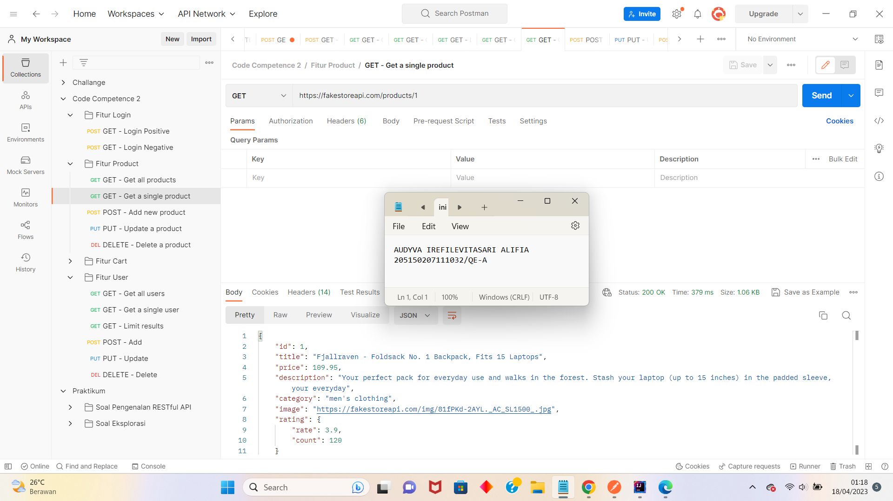

* Scenario POST

1. Add new product

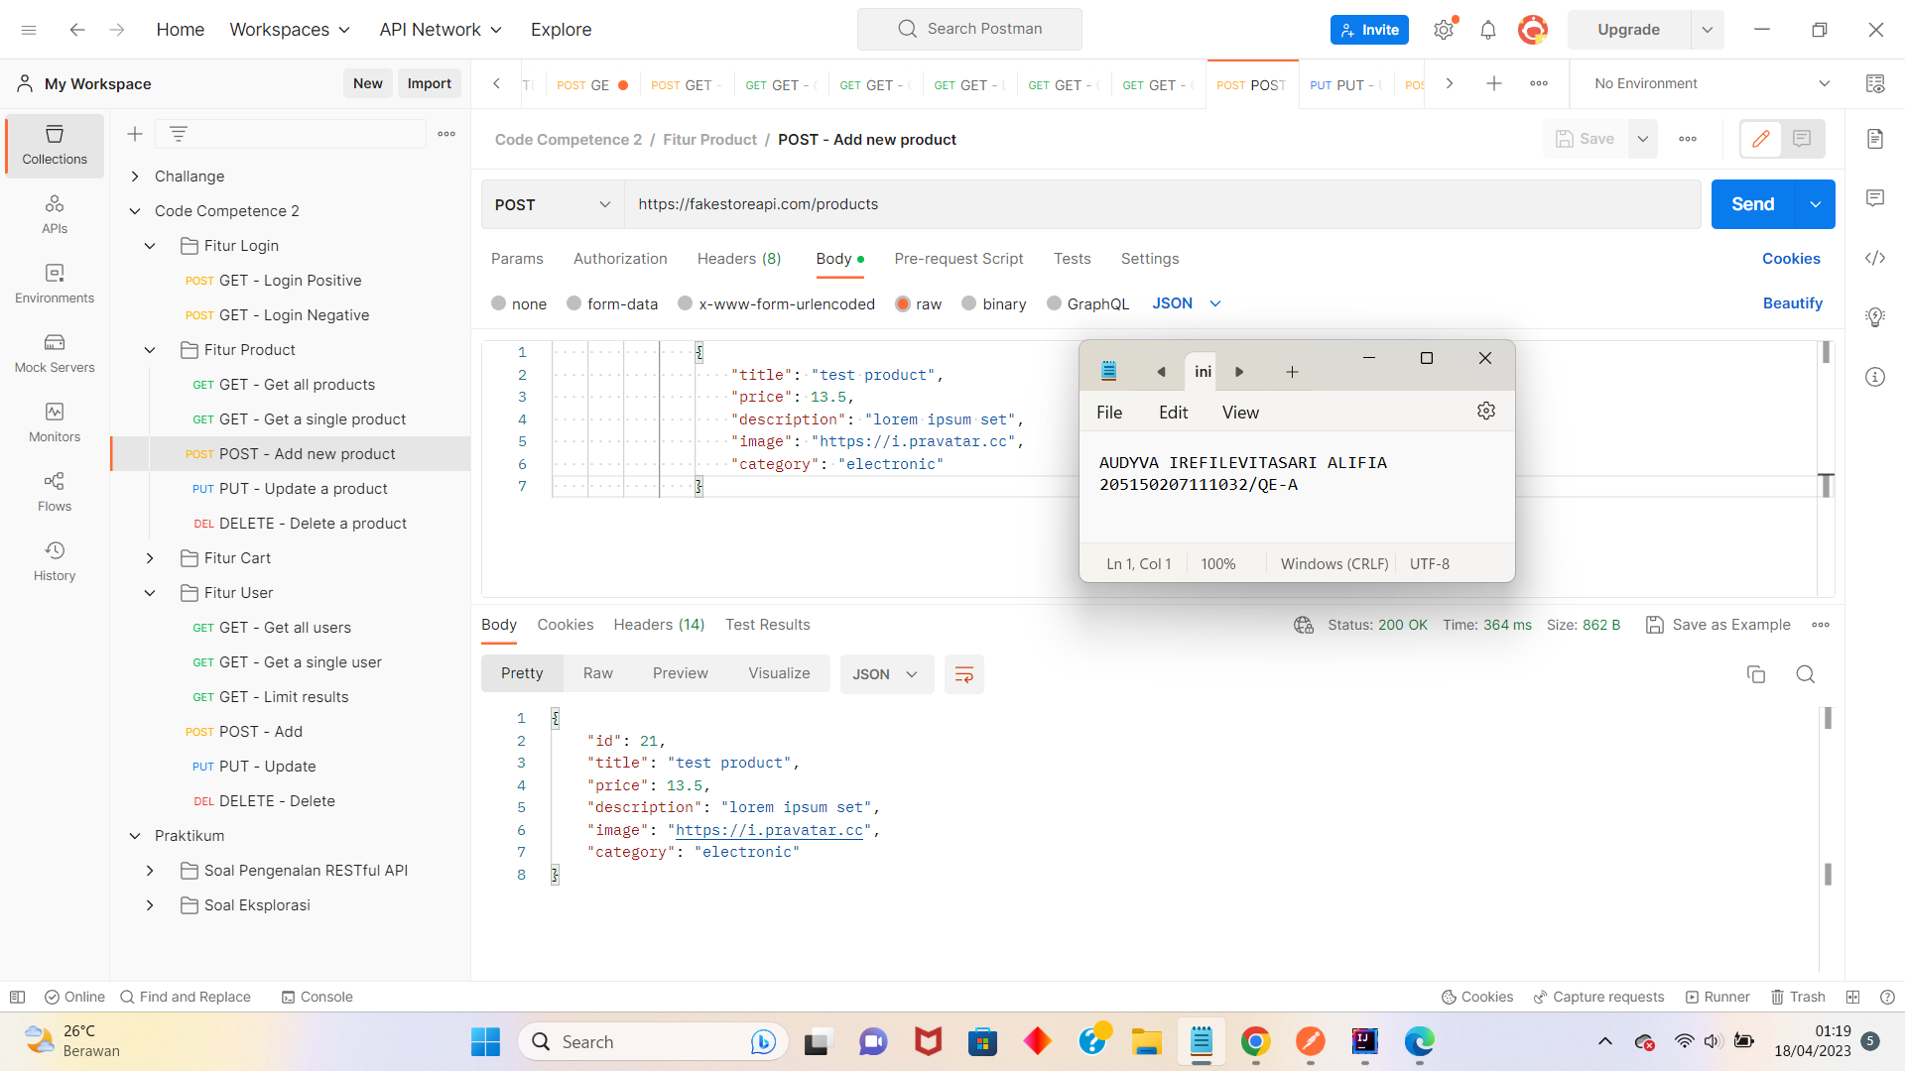

* Scenario PUT

1. Update a product

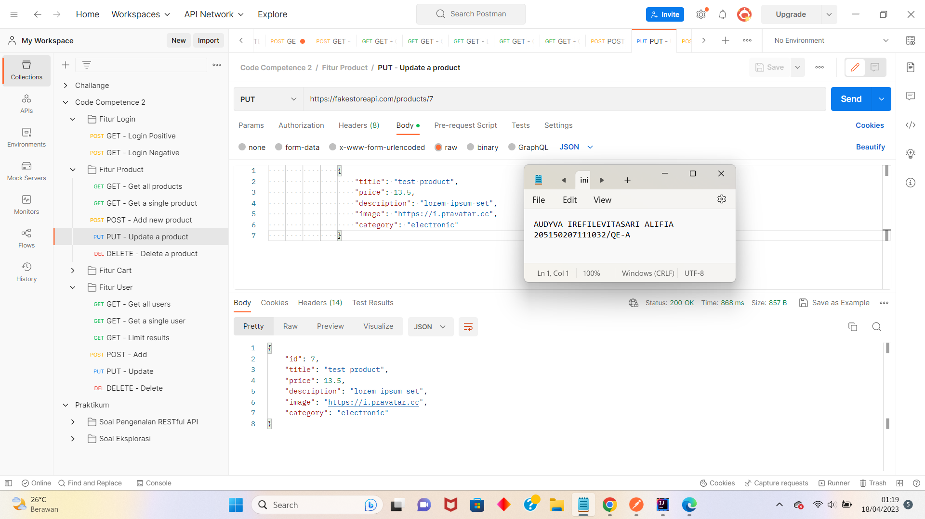

* Scenario DELETE

1. Delete a product

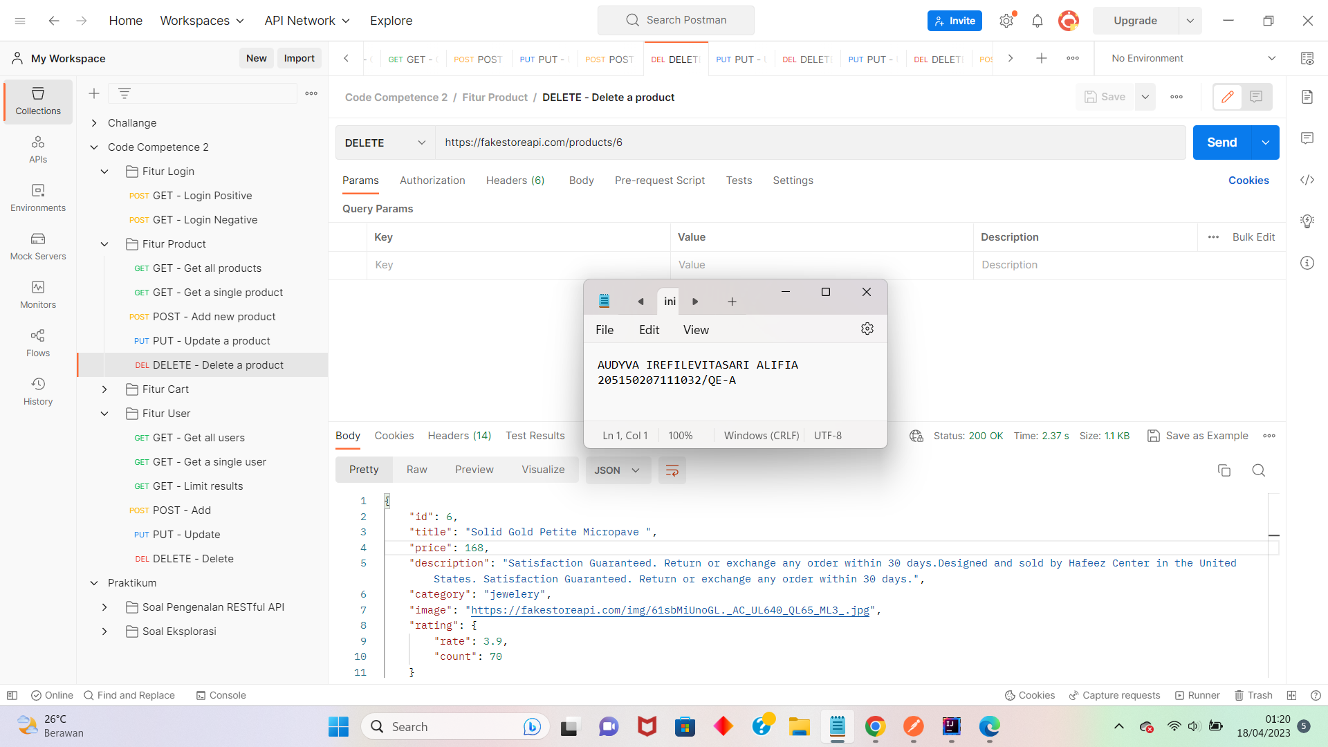

1. Fitur Cart

* Scenario GET

1. Sort results

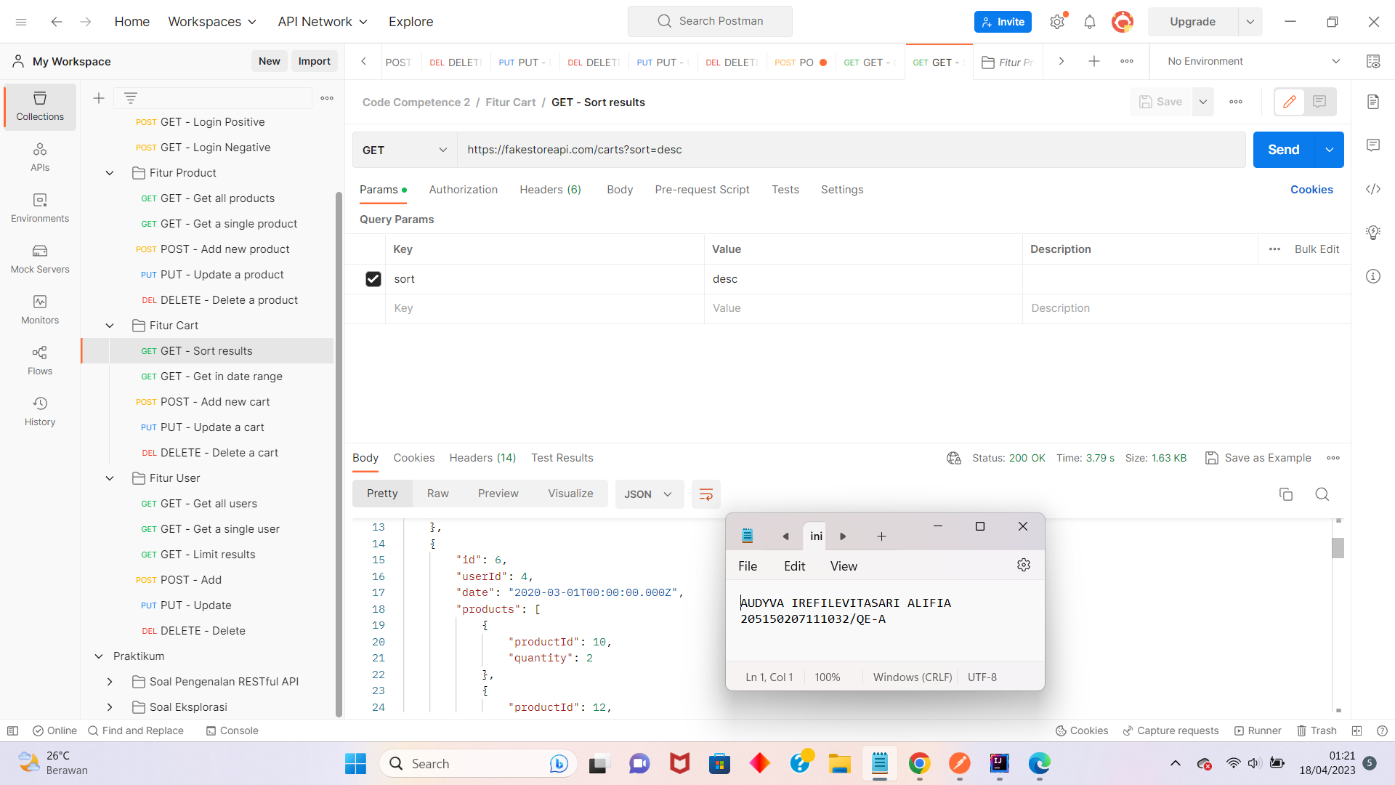

1. Get in date range

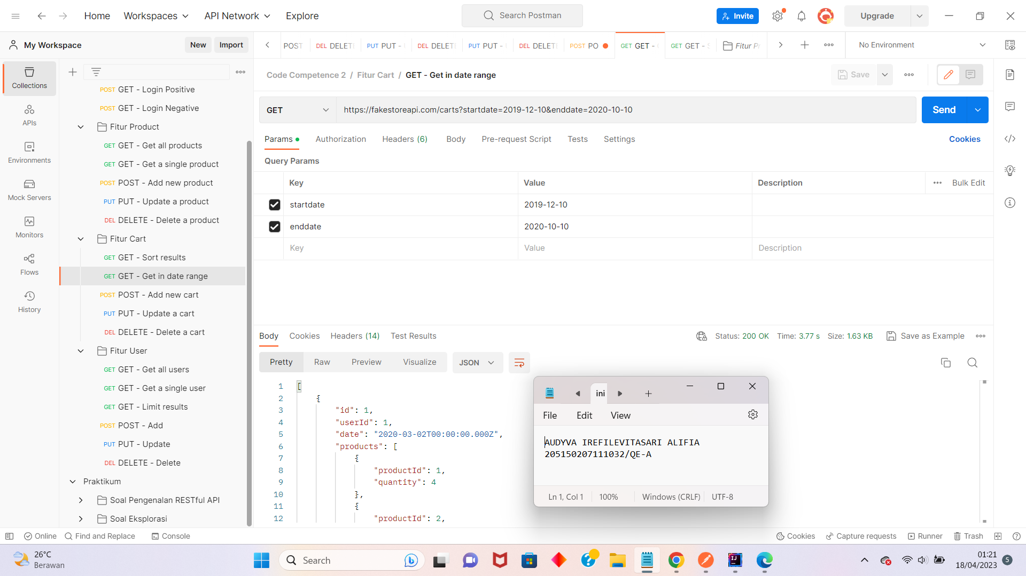

* Scenario POST

1. Add new cart

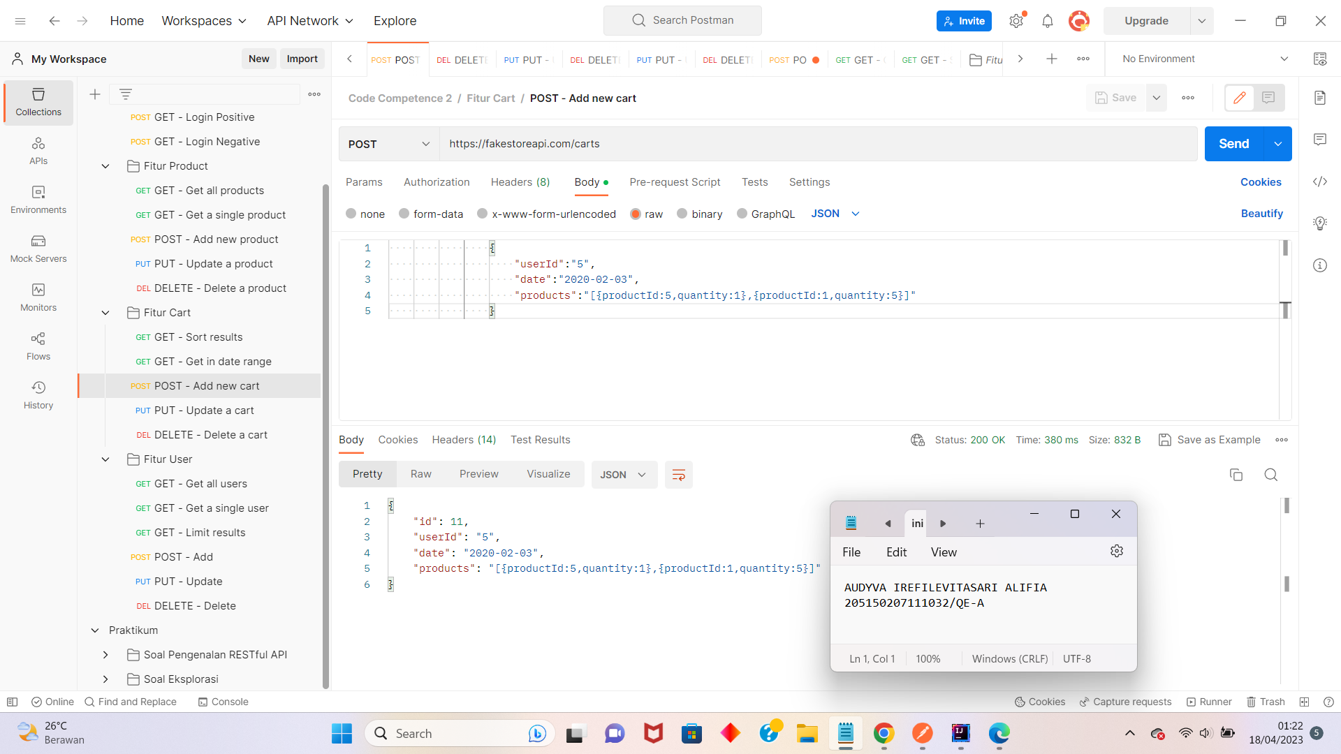

* Scenario PUT

1. Update a cart

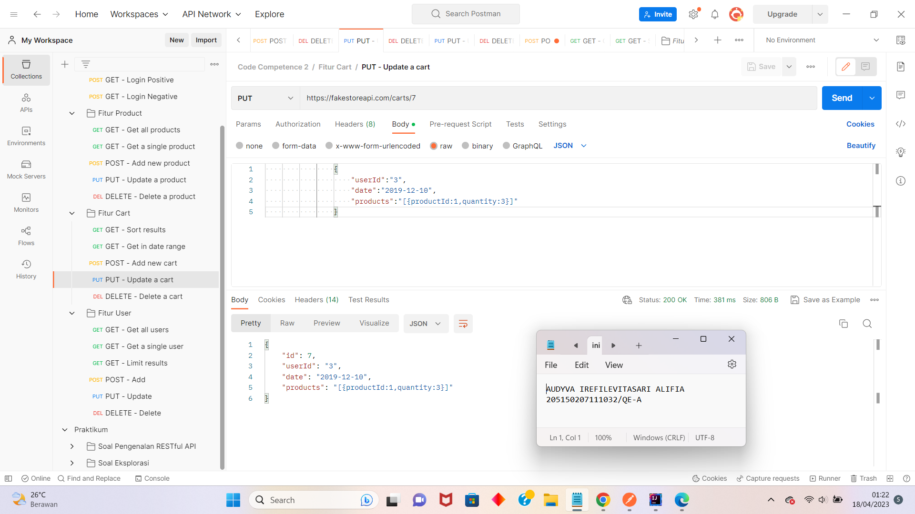

* Scenario DELETE

1. Delete a cart

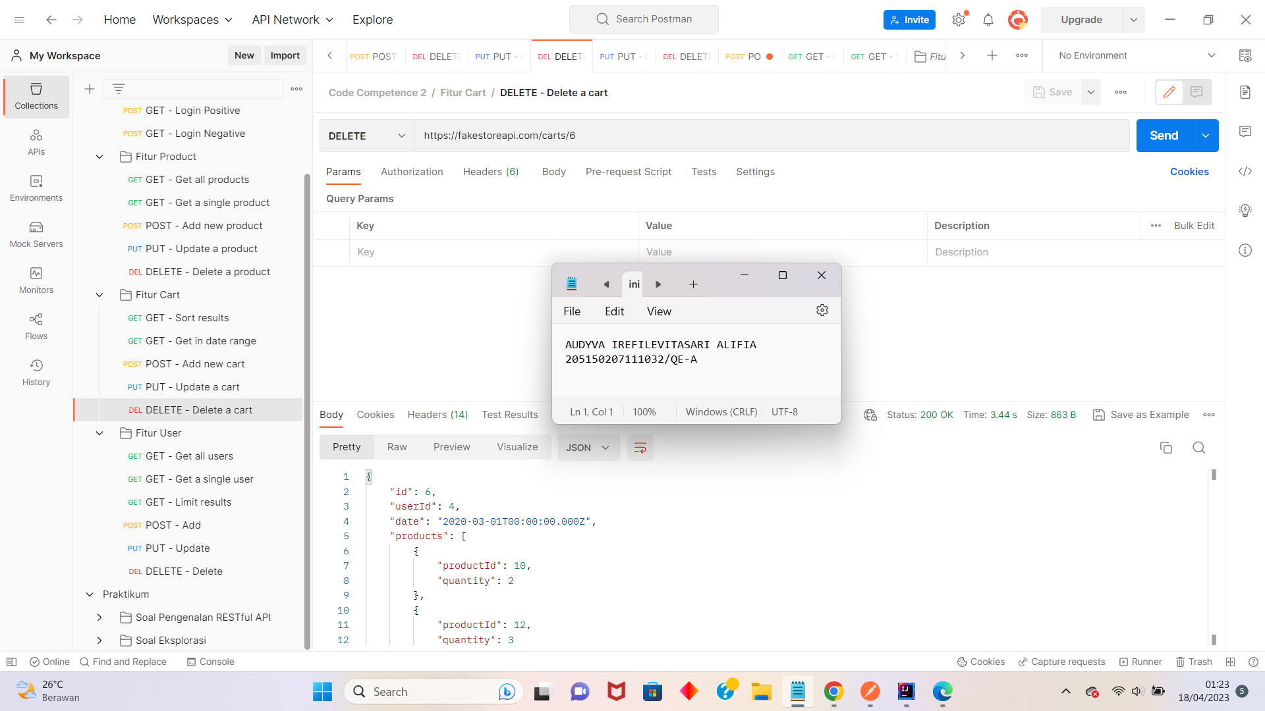

1. Fitur User

* Scenario GET

1. Get all users

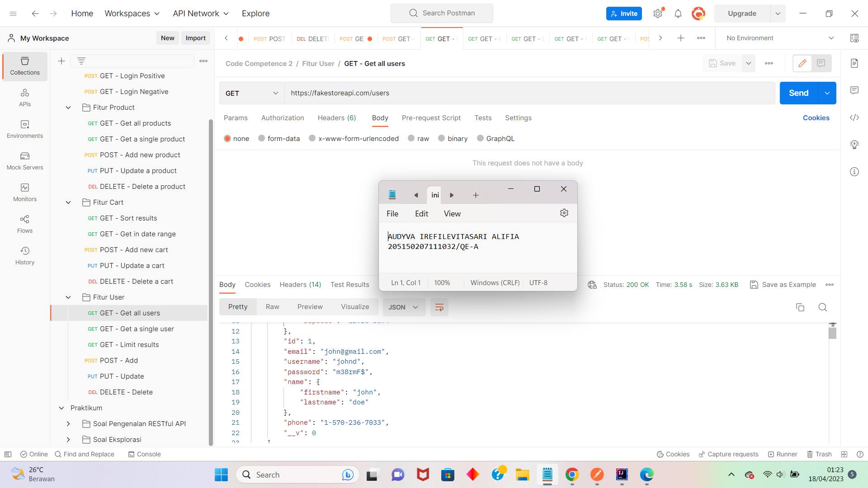

1. Get a single user

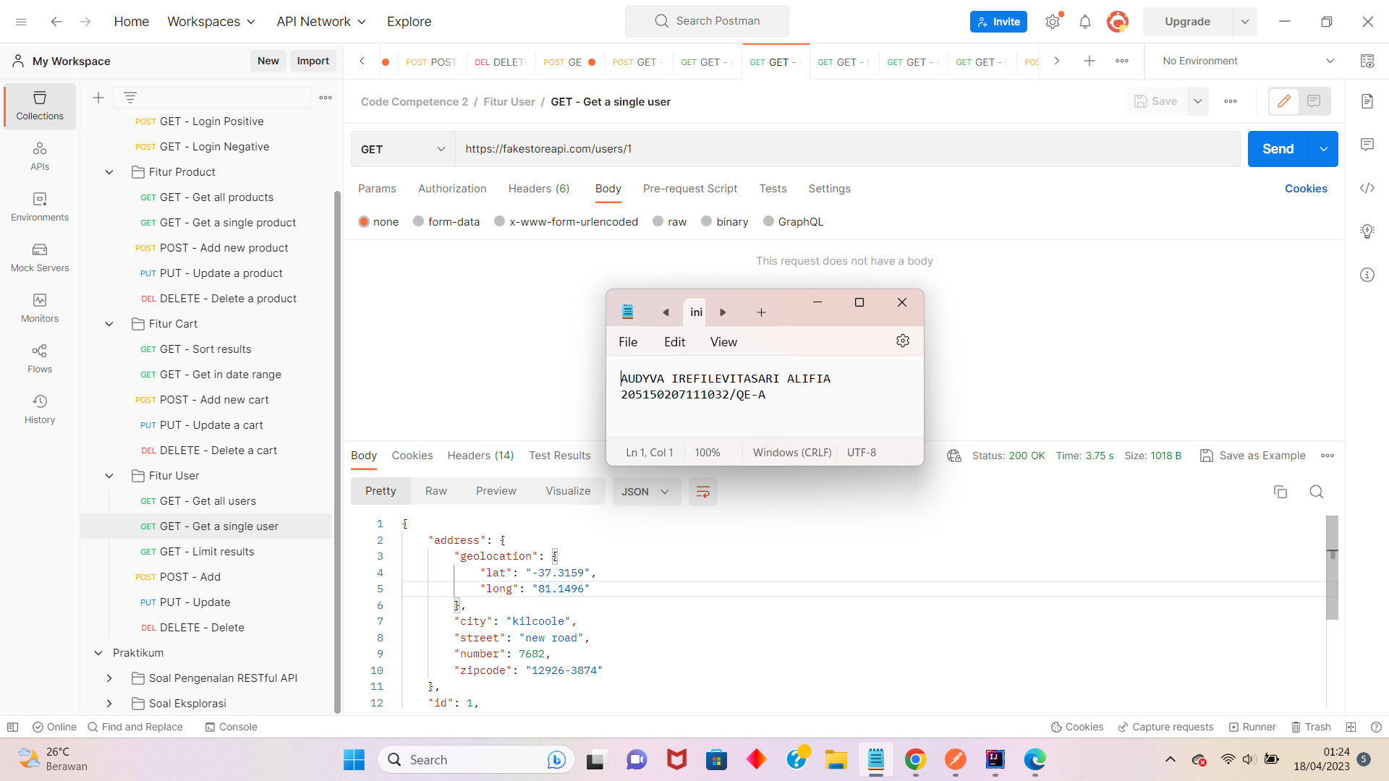

1. Limit results

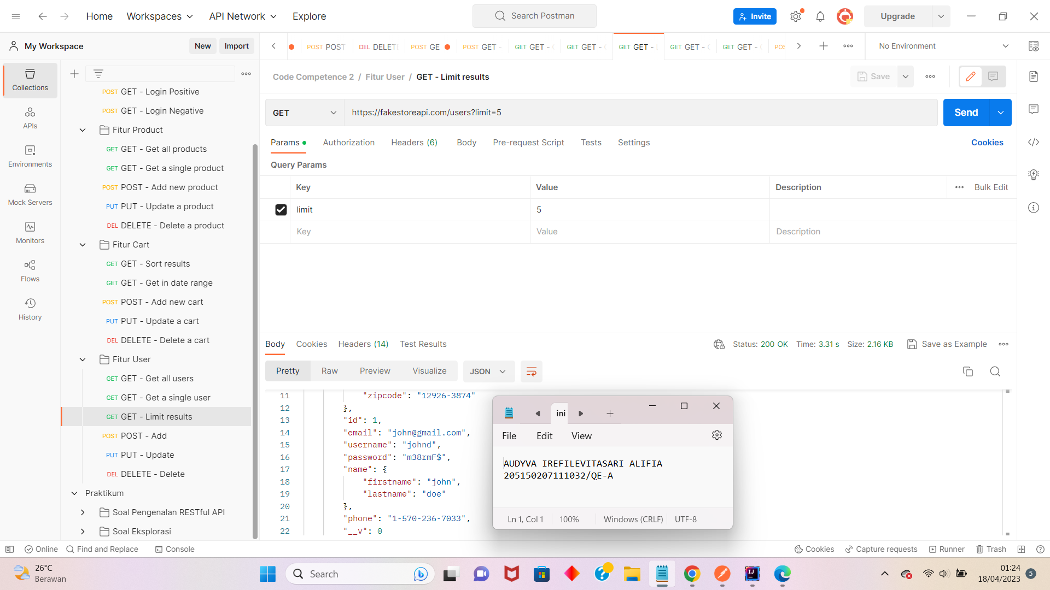

* Scenario POST

1. Add new user

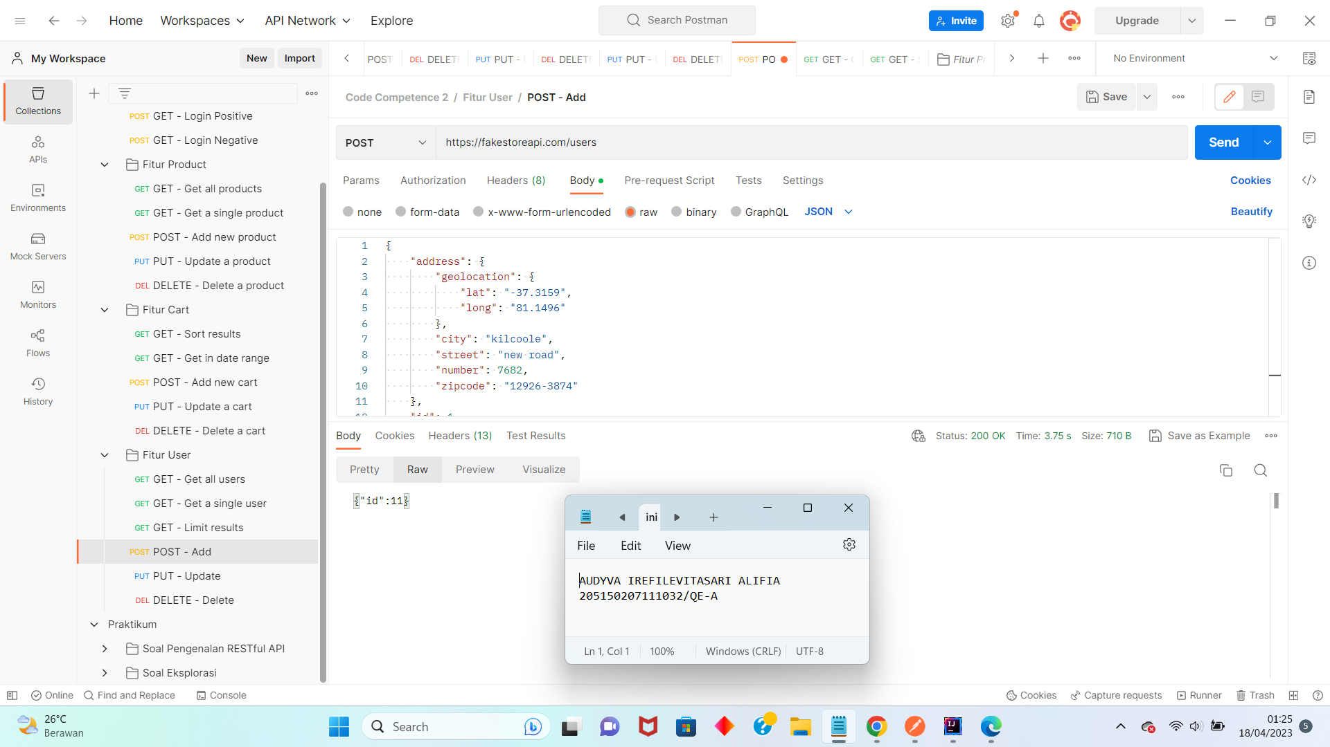

* Scenario PUT

1. Update a user

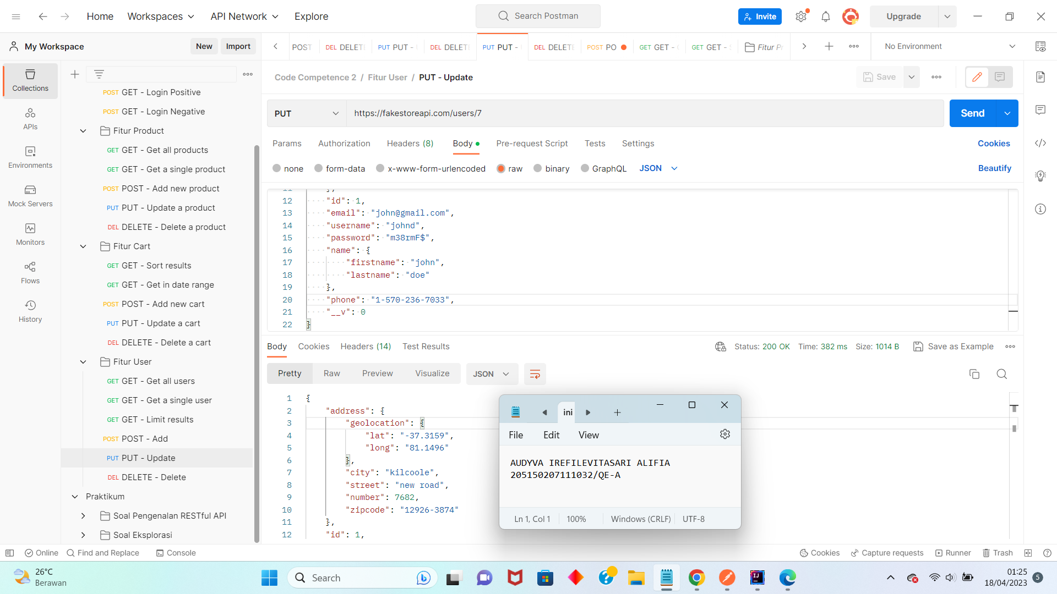

* Scenario DELETE

1. Delete a user

